

CEMP Guidelines on Litter on the Seafloor

(OSPAR Agreement 2017-06)

Source: EIHA 17/9/1 Annex 12

1 Introduction

1. Marine litter floats, sinks or gets cast on beaches. It is estimated that a large amount of the litter eventually sinks to the sea floor. Benthic or seafloor marine litter consists of similar items as those found on beaches and is dominated by plastic. Benthic marine litter data can be generated based on trawling surveys. Comparable classification methods as those applied to beach litter can be used to categorise and count litter items from the seafloor. This seafloor litter data can be used to assess types and trends in the distribution of seafloor litter. The following document will firstly introduce how to monitor marine litter during fisheries surveys and secondly present how this data can be evaluated.

2 Monitoring

2.1 Purpose

2.1.1 OSPAR agreed to substantially reduce marine litter in the OSPAR Maritime Area to levels where properties and quantities of marine litter do not cause harm to the coastal and marine environment (OSPAR North-East Atlantic Environment Strategy 2010). This is in line with the Marine Strategy Framework Directive (MSFD), which requires member states to achieve ‘good environmental status’ in Europe’s seas by 2020. The directive defines good environmental status based on 11 descriptors. To achieve a ‘good’ environmental status means, to protect the marine environment, prevent its deterioration and restore it where practical to use marine resources sustainably. Among the 11 descriptors incorporating 56 indicators of Good Environmental Status, descriptor 10 is identified as "Properties and quantities of marine litter do not cause harm to the coastal and marine environment". The following four criteria for monitoring progress towards achieving Descriptor 10 were identified (2010/477/EU):

D10C1:

The composition, amount and spatial distribution of litter on the coastline, in the surface layer of the water column, and on the seabed, are at levels that do not cause harm to the coastal and marine environment.

D10C2:

The composition, amount and spatial distribution of microlitter on the coastline, in the surface layer of the water column, and in seabed sediment, are at levels that do not cause harm to the coastal and marine environment.

D10C3:

The amount of litter and micro-litter ingested by marine animals is at a level that does not adversely affect the health of the species concerned.

D10C4:

The number of individuals of each species which are adversely affected due to litter, such as by entanglement, other types of injury or mortality, or health effects.

2.1.2. This OSPAR guideline is of relevance to MSFD D10 Criteria 1. Current knowledge related to the distribution of marine litter on the seafloor, its degradation and fate, its potentially harmful biological, physical and chemical impacts on marine life and habitats and the effectiveness of future measures is insufficient. To understand this part of the marine litter issue better information is required on both spatial and temporal differences in marine litter on the seafloor.

2.1.3. According to the monitoring guidance of the MSFD Technical Expert Group on Marine Litter (<http://publications.jrc.ec.europa.eu/repository/bitstream/JRC83985/lb-na-26113-en-n.pdf>) the best available way to survey seabed litter is by utilising existing trawl surveys, because litter monitoring can easily be added, covers a large area and can collect a large amount of litter for analysis. Marine litter data, awareness raising and removal can all be generated as by-products on existing trawl surveys. Especially fisheries cruises designed to quantify and investigate marine fisheries resources are known to generate useful data on marine litter which is “accidently” caught when trawling nets. The main challenge for marine litter monitoring is that there are differences in fisheries surveys in terms of aims, timing, locations and gear types. This complicates further marine litter analysis and needs to be taken into consideration for future assessments.

2.2 Quantitative Objectives

2.2.1. As stated in the 2012 OSPAR Advice Document on Marine litter (MSFD Descriptor 10): Target setting is difficult for almost all indicators under this descriptor for several reasons. Firstly, understanding the relationship between the types and amounts of marine litter in the environment and the degree of ‘harm’ caused at a population and in some cases individual level are not fully understood. Secondly, recognising that Contracting Parties have in place monitoring programmes at differing stages of implementation, we do not yet have a comprehensive understanding, thus it will take several years before enough data is available to robustly detect current trends across the OSPAR region. Finally, the effectiveness of potential management measures to reduce inputs is not completely understood. ICGML concluded in 2012 that for litter on the seafloor there is currently insufficient OSPAR wide data to assess impacts and current trends therefore a trend target would be most appropriate at this time.

2.2.2. When designing a monitoring programme, it is important to consider its power of detection. The power of the design is the probability that it will detect the difference we are interested in. As a design criterion one often prefers the ability of surveys to detect a specific reduction (e.g. 50%) over a ten-year period with 90% power. Some Contracting Parties have proposed decreasing targets in relation to Indicator 10.1.2 although most have indicated to allow progress to be monitored over time and compared among countries.

2.2.3. A cost-effective way to monitor seafloor litter is by conducting the monitoring programme during existing fisheries and environmental surveys which use bottom trawls to collect biota samples from near the seafloor and capture benthic macrolitter as a by-product. Programmes to monitor marine litter on the seafloor using existing trawling surveys have been introduced by several Contracting Parties, which led to the inclusion of seafloor litter in the OSPAR Common Indicator process.

2.2.4. Almost all Contracting Parties organise fisheries surveys using bottom trawls in the whole OSPAR region, often in overlapping areas (especially in Region II, III, IV). Therefore, seafloor litter data is gathered by individual countries on existing fisheries surveys as a by-product. A central data depository for seafloor litter data has been created by ICES and an accompanying ICES working group should be created in 2017/18. For this OSPAR assessment, two separate assessments were made as not one survey covered the entire region and no mixing of seafloor litter data from different surveys were done. For region II, III and the northern part of region IV seafloor data generated by the IBTS survey using a GOV trawl was used. For the assessment covering the Iberian coast and Golf of Cadiz seafloor litter data from the Spanish Groundfish Survey using a BAK trawl was used. Although both bottom trawls have a similar design, the smaller mesh sizes in the cod end of the BAK trawl probably lead to retention of higher amounts of seafloor litter.

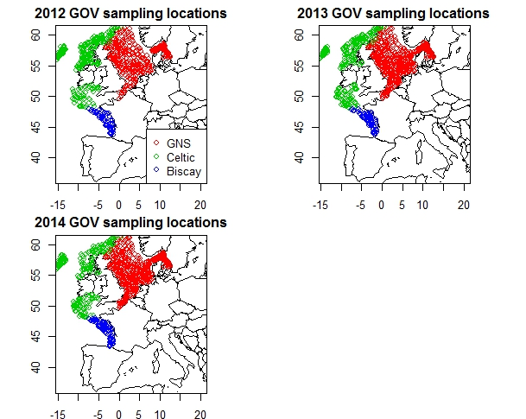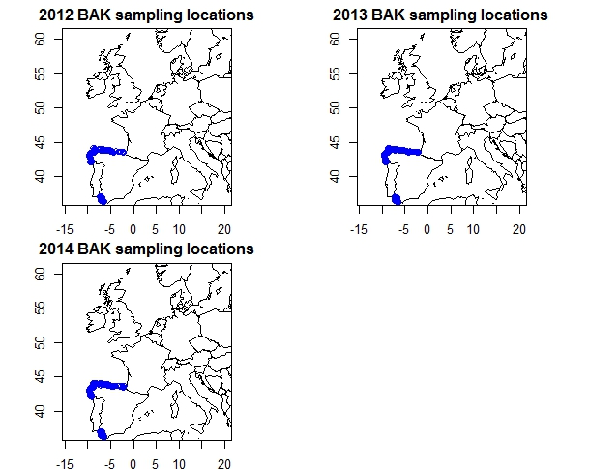

**Figure 1: Stations used for the assessment covering region II, III and the northern part of region IV (GOV) and the assessment covering the Iberian coast and Golf of Cadiz (BAK) haul locations**

2.3 Monitoring Strategy

2.3.1 Most trawl surveys suited for marine litter data collection are targeted on fisheries objectives and thus there is a risk that surveys may be discontinued for reasons outside the scope of MSFD litter monitoring. Initiating a targeted marine litter programme for higher resolution temporal trend monitoring would, however, involve additional costs, and these would depend on the magnitude of the time trend to be detected with a level of statistical certainty and the time period within which it is to be found. To achieve such detection levels, dedicated marine litter surveys would have to take place and go out to specifically collect benthic litter data. This is not only costly, but also requires that we will have to trawl the seafloor even more. However, many European countries already undertake environmental and fisheries trawl surveys, therefore standardisation of marine litter data collection and reporting among OSPAR Contracting Parties enlarges the available dataset and thus ability to detect small changes in the abundance of seafloor litter. The current monitoring strategy and sampling procedures are driven by the requirements of fisheries surveys.

2.4 Sampling Strategy

2.4.1 Bottom trawl surveys are widely used for monitoring demersal stocks when only an index of abundance is required. The estimation of total biomass is based on the catch per unit of effort (or unit area), however, involves several crucial assumptions, leaving such estimates rather imprecise. The mean catch (either in weight or in numbers) per unit of effort or per unit of area is an index of the stock abundance (i.e. assumed to be proportional to the abundance). Similar assumptions can be made in relation to the number of caught litter items, nevertheless there will be a relationship on average. If there is twice as much litter on the seafloor, you would expect to catch twice as much litter on average. Fisheries surveys have hardly changed over time in terms of sampling procedure. The litter data they generate therefore allows us to set baselines and trends based on sound methods in an environmental matrix where information normally comes at high cost.

2.4.2 Given that it is the fisheries surveys that will be driving the sampling, the marine litter programme and assessment method will need to be flexible. As a result of different monitoring strategies and sampling procedures, varying types of marine litter data will be collected on different trawl surveys. If different trawls are used, parallel or alternate hauls should be carried out to estimate correction factors for pooling of marine litter data. In the absence of such correction factors, mixing of survey data need to be avoided (e.g. GOV and BAK assessment).

2.4.3 Within the OSPAR region most fish trawl surveys are coordinated by ICES expert groups. The survey data are covering the Baltic Sea, Skagerrak, Kattegat, North Sea, English Channel, Celtic Sea, Irish Sea, Bay of Biscay and the eastern Atlantic from the Shetlands to Gibraltar. DATRAS (the Database of Trawl Surveys) has been developed to collate and document the survey data, assure data quality, standardise data formats and calculations, and ease data handling and availability. Those existing frameworks and databases have been adapted by the ICES Data Centre to accommodate OSPAR seafloor litter data.

2.4.4 For each survey, the following information was recorded: the definition and specification of the survey, the positions of stop and start of each trawl and its technical specification e.g. wing spread, mesh size of net, cod end and blinders. After each tow, the catch was deposited in the fish pound or hopper before being sorted, then all litter items were manually picked from the entire net, including ground ropes, fishing lines, hopper and cod end and classified according to the classification system as listed below. When fragments from one item are found and clearly are defragmented as a result of the trawling, then these need to be counted as one item. For fishing lines being caught in one haul, items can be categorised as monofilament or entangled. A haul can contain several monofilament and entangled lines which need to be counted individually. The litter items are categorised as present in the haul, no further separation or disentanglement is required. The classification system, is composed of six main categories of litter (Plastic, Metal, Rubber, Glass, Natural and Miscellaneous), each divided into sub-categories (39 in total). An overview can be found here:

|  |  |  |  |
| --- | --- | --- | --- |
| **A: Plastic** | **B: Metals** |  | **Related size category** |
| A1. Bottle | B1. Cans (food) |  | A: <5*5 cm= 25 cm2 |
| A2. Sheet | B2. Cans (beverage) |  | B: <10*10 cm= 100 cm2 |
| A3. Bag | B3. Fishing related |  | C: <20*20 cm= 400 cm2 |
| A4. Caps/ lids | B4. Drums |  | D: <50*50 cm= 2500 cm2 |
| A5. Fishing line (monofilament) | B5. appliances |  | E: <100*100 cm= 10000 cm2= 1 m2 |
| A6. Fishing line (entangled) | B6. car parts |  | F: >100*100 cm = 10000 cm2= 1 m2 |
| A7. Synthetic rope | B7. cables |  |  |
| A8. Fishing net | B8. other |  |  |
| A9. Cable ties |  |  |  |
| A10. Strapping band |  |  |  |
| A11. crates and containers |  |  |  |
| A12. diapers |  |  |  |
| A13. sanitary towel/tampon |  |  |  |
| A14. other |  |  |  |
|  |  |  |  |
| **C: Rubber** | **D: Glass/ Ceramics** | **E: Natural products** | **F: Miscellaneous** |
| C1. Boots | D1. Jar | E1. Wood (processed) | F1. Clothing/ rags |
| C2. Balloons | D2. Bottle | E2. Rope | F2. Shoes |
| C3. bobbins (fishing) | D3. piece | E3. Paper/ cardboard | F3. other |
| C4. tyre | D4. other | E4. pallets |  |
| C5. Glove |  | E5. other |  |
| C6. other |  |  |  |

Example of log sheet for station specifics and trawl conditions:

|  |  |  |  |  |  |  |  |  |  |
| --- | --- | --- | --- | --- | --- | --- | --- | --- | --- |
| **START** | **Trawl#** | **TIME start** | **Lat(N) start** | | | **Long(W) start** | | | |
|  |  |  | | |  | | | |
| **STOP** | **Date** | **TIME end** | **Lat(N) end** | | | **Long(W) end** | | | |
|  |  |  | | |  | | | |
| **SEA & VESSEL CONDITIONS** | **Sea State** | **Current Speed** | **Current Direction** | **Vessel Speed** | **Vessel Direction** | | **Wind Speed** | **Wind Direction** |  |
|  |  |  |  |  | |  |  |  |

2.4.5 The use of an appropriate field guide with examples of each litter type will assist survey team members to be consistent in litter characterization. The use of standard lists and definitions of items will enable the comparison of results between different surveys, regions and environmental compartments. Nevertheless, renaming or adding marine litter categories to adjust for local differences might have to take place when making regional assessments.

Example of Cefas Seafloor Litter Monitoring Sheet:

|  |  |  |  |  |  |
| --- | --- | --- | --- | --- | --- |
| Cruise: |  | | | | |
| Station: |  | | | | |
| Date: |  | | | | |
| Litter Item Number | Category | Size | Picture | Fouling | Description (e.g. weight, brand, …) |
|  |  |  |  |  |  |
|  |  |  |  |  |  |
|  |  |  |  |  |  |
|  |  |  |  |  |  |

2.5 Quality assurance/ Quality Control

2.5.1 It is important that the data generated is of acceptable quality. To ensure the quality and integrity of benthic marine litter monitoring data, the use of quality control and assurance measures, such as training for operators and use of standard picture list of litter items need to be introduced.

2.5.2 QA/QC procedures for seabed litter should form part of the future ICES Working Group on Marine Litter.

2.6 Data reporting, handling and management

2.6.1 The ICES Data Centre has taken the data reporting forward via existing database systems, DATRAS. There will be no changes to DATRAS, but litter data collected during a trawl survey will be storable and connected to the DATRAS database. The DATRAS Unique key information will be used to link litter data to the DATRAS haul data to ensure a streamlined reporting process.

2.6.2 The data will be by default available through the ICES Data Portal on the ICES website (<https://datras.ices.dk/Data_products/Download/Download_Data_public.aspx>). This application has a download capability where csv files of the data points can be downloaded along with accompanying meta data. Extra columns have been added to filter data by OSPAR area, MSFD regions, EEZ and territorial waters This application also offers standard web services which can be used by statistical packages i.e. R scripting

3 Assessment

3.1 Data acquisition

3.1.1 Data is collected annually by the ICES datacentre and an extraction can be made from the ICES website. An overview of the submission status of all available seafloor litter data can be found here:

<https://datras.ices.dk/Data_products/Submission_Status.aspx> .

3.1.2 Since 2017, data can be downloaded via the ICES Data Centre:

<https://datras.ices.dk/Data_products/Download/files/Trawl_Litter_OSPAR_V6_20170310.Zip>

3.2 Preparation of data

3.2.1 Normalisation needs only arise if multiple trawl surveys are combined. In order to amalgamate benthic litter data generated by different trawl types, there is a need to define an appropriate factor between the litter catchability of different trawls. Simultaneous or parallel trawls are therefore required. In the absence of correction factors for different trawls, only one fisheries survey is used to assess an OSPAR area

3.2.2 In the first OSPAR wide seafloor litter assessment some pragmatic decisions were taken:

* Rows with missing values were deleted in the original data file
* Values of -9 in the ‘items’ field were recoded as zero.
* Only years 2012-2014 were available for this assessment.
* Two assessment were made based on GOV trawl values for the Greater North Sea, The Celtic Sea and The Bay of Biscay and BAK trawl values for the north-western Iberian shelf and The Golf of Cadiz.
* The data format was modified for statistical use
* The following was used to define haul ‘area’: area = 1,000,0000 * litter / (doorspan*distance) km2.
* The mean of the door / wing ratios (4.18) was calculated to use as an approximate conversion factor.
* There were two ways of coding the litter types: (C-TS) and the revised way (C-TS-REV). Some simple R coding is used to transfer between both category lists (C-TS-REV & C-TS), it regroups the sanitary waste items in the plastic category.

*Aggregation and integration of data acquired*

3.2.3 If correction factors are available, marine litter data from different national fisheries surveys can be aggregated and/or compared between OSPAR and MSFD regions.

An overview of existing trawl surveys in OSPAR and MSFD regions can be found here: <https://datras.ices.dk/Data_products/Download/Download_Data_public.aspx>

A Summary of International Bottom Trawl Surveys (IBTS) cruises in Western Europe can also be found in the EU “Technical Recommendations for the Implementation of MSFD Requirements” document at Table 2, page 27:

<http://publications.jrc.ec.europa.eu/repository/bitstream/JRC67300/msfd_ges_tsg_marine_litter_report_eur_25009_en_online_version.pdf>

3.3 Assessment criteria

3.3.1 There are currently no assessment criteria available for seafloor litter assessments. Baseline values, which can serve as a basis for comparison with the subsequently acquired data are given below. The values set out in this document do not represent target values or legal standards under the OSPAR Convention and should not be used as such. The use of this set of criteria is considered an interim solution for the purposes of the intermediate assessment in 2017 until more appropriate approaches to defining certain assessment criteria can be agreed upon and implemented, taking into account, *inter alia,* the requirements of the EC Marine Strategy Framework Directive.

* *Defining assessment unit/scale (Temporal and spatial)*

Yearly in all OSPAR and MSFD regions with long term seafloor litter data

* *Baseline/ reference level:*

Widespread distribution of litter items, especially plastics, was discovered on the seabed of the Greater North Sea, the Celtic Sea, the Bay of Biscay, the Iberian Coast and the Gulf of Cadiz.

*Baseline values for the Greater North Sea in 2012:*

* + *Total items:* 28.842 (25.08,32.604) items/km2
  + *Plastic items:* 17.974 (15.466,20.064) items/km2

*Baseline values for the Celtic Sea in 2012:*

* + *Total items:* 13.794 (10.868,16.72) items/km2
  + *Plastic items:* 11.704 (9.196,14.212) items/km2

*Baseline values for the Bay of Biscay in 2013:*

* + *Total items:* 96.14 (78.166,115.786) items/km2
  + *Plastic items:* 75.658 (62.7,88.198) items/km2

*Baseline values for* the Iberian Coast and Golf of Cadiz in 2013

* + *Total items:* 190.1 (143.5,245.76) items/km2
  + *Plastic items:* 113.2 (89.8,139.2) items/km2

*To be defined for OSPAR/MSFD Regions*

* *Environmental target*

This is set individually by Contracting Parties

Note: one should use the results of the power study to have an indication of detectable change in total amounts of litter.

3.4 Spatial Analysis and / or trend analysis

3.4.1 Due to the lack of long-term data sets no temporal trend analysis was done for the first assessment when this guideline was written. The following methodology is proposed, all seafloor litter data reflects presence or absence. Thus, to give a good representation of the extent of litter on the seafloor and to make correct comparisons across time, for each year, one can create the variable “percentage of trawls in which the litter item was recorded”. Whilst we are confident that the data generated by individual surveys correctly counted litter items, we can use the same percentage variable to define litter for all survey. This is partly for ease of comparison between surveys but also because the distribution of the number of litter items caught per trawl is often highly skewed. That is, generally observations are 0 or 1, but there are some very high counts. These high counts could overly influence simple yearly means and transforming the data by taking natural logs will be problematic due to the high proportion of zeros.

3.4.2 For temporal trend analysis the data should thus be expressed as the percentage of trawls in which the litter item was recorded. To perform formal statistical evaluation of potential trends, the Mann-Kendall non-parametric test can be performed on the yearly means using the R software package emon (<https://r-forge.r-project.org/projects/emon/>), with the function mannkendall (MK). Effectively, this method considers each yearly mean and counts the number of means in future years that are greater than it (assigned a positive number) and the number that are less than it (assigned a negative number). The sum of these two numbers represents the observed MK statistic. This observed statistic is then compared with the value that would be obtained under the null hypothesis of no trend. This is achieved using a randomisation procedure that involves randomly allocating years to litter means - thus calculating the null distribution of the MK statistic. Two-sided tests need to be performed as there is no *a priori* knowledge of whether the trend might be positive or negative.

3.4.3 In the spatial analysis, the data are presented as abundance in number of marine litter items km-2 of seafloor. Mean values of litter abundance were calculated for all years and areas where sufficient data was available, 2012 data could be selected to synchronise with the start of the MSFD (initial assessment) and as such represents the baseline or initial abundance of litter items km-2 on the seafloor. For total litter and for plastic, 95% bootstrap confidence intervals are also given using the percentile method.

3.4.3 For the power studies we have used the trend.power function in the R library emon. The power should be calculated with total litter counts for each of the three areas: Celtic, GNS and The Bay of Biscay. The sample size for each year is fixed at the following values, which corresponded roughly with the number of stations taken in each year: Celtic=225, GNS=500, Biscay=75. A starting mean for each region corresponding to the observed 2012 mean should be assumed. The power can then be calculated for 10%, 20% and 30% increases over 5, 10, 15, 20, 25 and 30 years. As the number of years’ increases, there is more data to detect the trend – although the change per year gets smaller. Possibly, this could be repeated but fixing the increase to be X% per year. A negative binomial distribution is assumed for the distribution of numbers of items per haul. The results of the power study for the first assessment are shown in Figure 2. A separate assessment should be done, using only the Spanish BAK hauls. The sampling locations are shown in Figure 1. There were 182 hauls in 2012, 197 hauls in 2013 and 160 hauls in 2014. The power results for Spain, assuming a sample size of 182 are shown in Figure 3.

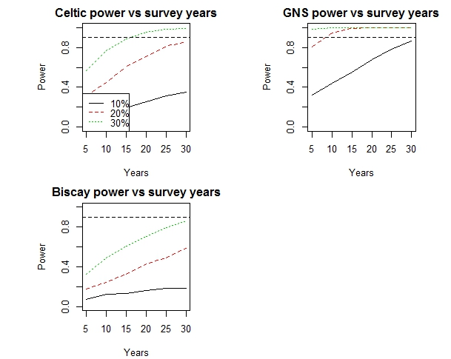

**Figure 2: Power plots for total litter items per haul. The x-axis is the number of years of survey and the different lines represent linear changes in trend**

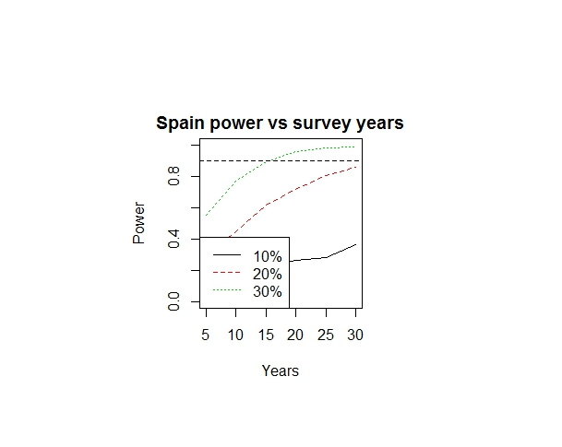

**Figure 3: Power plots for total litter items per BAK haul. The x-axis is the number of years of survey and the different lines represent linear changes in trend**

3.5 Presentation of assessment results

3.5.1 The following results should be part of the seafloor litter assessment:

* Number of items per km2, total and by (sub)category per year and region (mean & 95% bootstrap confidence intervals).
* Trend analysis (minimum of 5 years’ data required)
* Figures showing smoothed predictions of the total number of items per km2, total plastic counts per km2 and probability a haul contains plastic. Ideally, the number of items found should be standardised to the area of the haul. This is effectively the distance of the haul multiplied by the cross-sectional area of the net.
* Power study to define detectable change with number of stations

3.5.2. Figures for the assessment [add reference to assessment sheet] represent spatially smoothed predictions of the litter type at a grid of points (this is using data combined over years). The grid over the whole map is 200 (longitude) by 127 (latitude) of equally spaced points. Grid points that are more than 20 km from a haul location are not used. The plots have been smoothed using a Generalised Linear Model (9) with longitude and latitude as the explanatory variables. The counts have been modelled using a negative binomial family and the litter per km2 values have had a ln(x+1) transformation to get them approximately Gaussian (with limited success). For the litter per km2 plot, we back-transformed the smoothed values using an exponential minus 1 transformation. The plots are thus approximately median levels on the original scale.

4 Change Management

4.1 All changes related to data generation and management should be taken forward by ICES. Changes in relation to the assessment and technical content will fall under the responsibility of the OSPAR ICGML and should be signed off by the OSPAR EIHA committee.